Videoconferencing tips
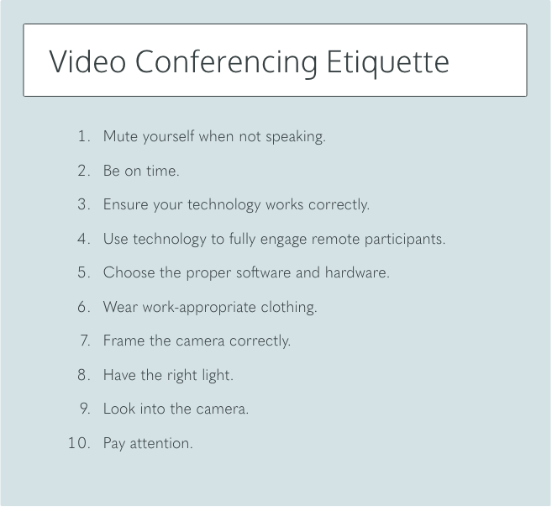

- If you can, find a private place to take the call. If not, use headphones to minimize background noise. If you have roommates, partners, or family members who are also home let them know beforehand that you’ll be in a meeting to minimize interruptions.

- Set up your device or camera so that it has a clear view of you. Don’t sit too far from, or too close to, the camera.

- If you’re using a separate camera, place it near your screen — it’s best to put the camera at eye level, so that when you’re looking at the screen, it appears as if you’re looking at the person you’re talking to.
- Clean up the area around you. Open up the camera on your laptop or switch on your external camera and see what’s visible in the background before the call, and check that you’re comfortable showing that on a video call (so put away your laundry and make sure whatever’s on your walls is work-appropriate).
Setting up a virtual background is a great way to ensure your privacy during a video call. There are further resources on Hub Central for how to do this.
- Mute your side of the call if you’re not speaking. Your microphone can pick up a lot of background noise, so muting allows others on the call to easily hear who’s speaking. Also, if you need to get up or move around or do something else during the call it’s a good idea to switch off your video to avoid causing any distractions.

- Keep in mind that you’re more visible on video calls than in offline meetings, since you get to see close-ups of everyone’s face individually instead of a whole group of people at once. It’s often helpful to also see your own face on screen, just as a reminder that you’re on camera, and so you can see what others are seeing.

- If you do need to share your screen during a video call, take a few seconds to prepare before you hit that share button. Clear your desktop of any extra tabs or programs you may have open and make sure any private or sensitive information is hidden.

- In terms of looks, you do not need to have a fancy haircut, but it does need to be neat. Don't go straight from waking up into a teleconference. Give yourself time to take a shower, comb your hair, and otherwise get cleaned up

- Consider having a meeting facilitator — often, but not always, the person who called the meeting. The facilitator is responsible for:
  - providing an agenda to participants — ahead of the meeting is nice, but minimally at the start of the meeting — that includes an overview of topics to be covered and planned outcome;
  - establishing the visual or verbal cues, such as raising a hand, to indicate when someone wants to actively contribute verbally to the meeting;
  - engaging participants at all locations to ensure discussion understanding, and alignment;
  - limiting “side conversations” and multitasking or ensure all participants are made aware of that content;

