Traditionally we have always had a hard time of enticing and engaging dads in our school for formal information sessions, so this year… it was time to think outside the box!

What was the challenge?

Dads have been reluctant to engage at our school, some dads work and some just see the child rearing as the domain of their wives. In an effort to start highlighting to dads the importance of their role in their child’s upbringing, we invited Rob Koch, from Monash Men’s Health to speak with the dads about ‘*Why Dads Are Important’*.

Your advice?

As encouraging dads into school activities can be problematic and we usually see dads appearing to collect students, the Preps always plan a “Fabulous Father’s Day” afternoon of the last day of school before Father’s Day.

This year, we invited the dads to come ¾ of an hour earlier and sourced Rob Koch from Monash Men’s Health to deliver a short, sharp, engaging presentation about just how important dads are to their children and how much better children do when their dads are actively involved in their lives.

The dads that attended said that they enjoyed the content and how it was delivered; several dads even went up to speak with Rob after the presentation asking for more information. We arranged for interpreters and tried to keep female staff at a minimum. (Although I think we still had a few too many women about, in retrospect.)

Afterwards, the dads went outside into the sunshine to enjoy a wide range of fun activities with their children. And, there were smiles all round!

What worked? What didn’t?

When trying to get a new program off the ground, try to think of an existing, highly successful program you may be able to ‘piggy back’ on. We used the existing Prep Father’s Day afternoon as a springboard for the parenting session because of the large numbers of dads who attend each year. It must be noted that we had spoken with a number of agencies about the delivery of this type of program for dads and there were many agencies wanting to be involved. However, the most important thing was to choose one that we felt targeted our audience . . . . our specific context. From here, we will be looking to engage Rob for other activities in the future, including a modified Pit Stop Parenting program.

**“It was very interesting. I would like to learn more.” Ishaq**

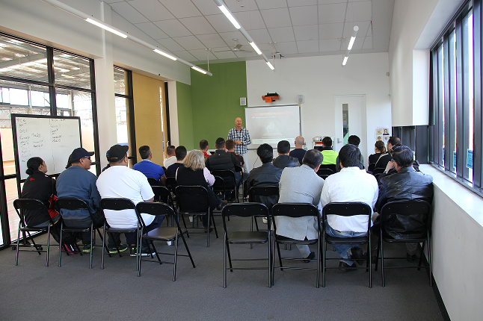

**View all case studies at www.communityhubs.org.au/resources**